How to Setup Wireless Access Control of W312A
Step 1: Power on the AP, and connect PC to AP’s LAN port by a cable (as the following illustration);
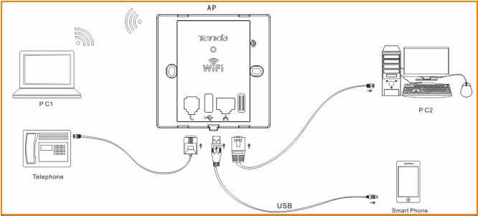

Step 2: Set a static IP for local area connection within the following range: 192.168.0.X (2-254), and with the subnet mask: 255.255.255.0;
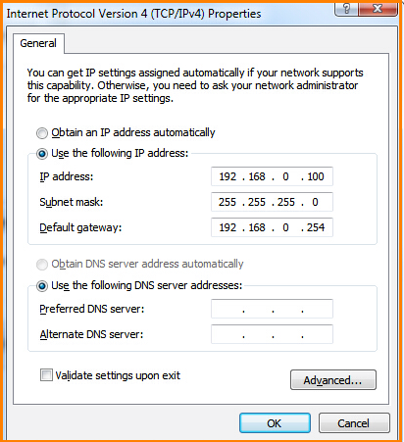

Step 3: Launch the browser and login AP’s web page;
- Launch IE browser and input 192.168.0.254 in the address bar and press Enter;
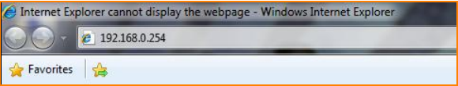
- Type in the default username and password (admin for both) and click Login;
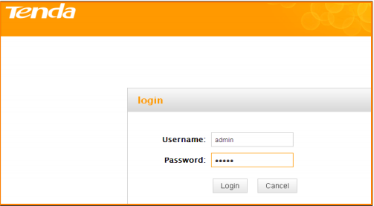
- Enter this device’s web page;
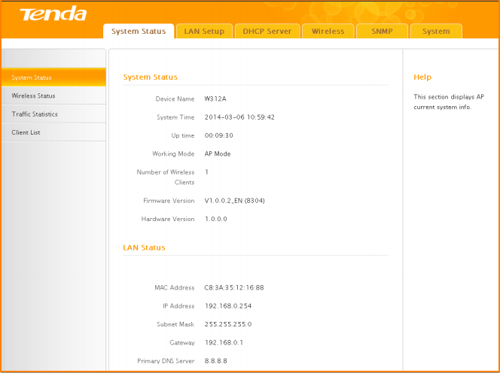

Step 4: Setup Wireless Access Control.
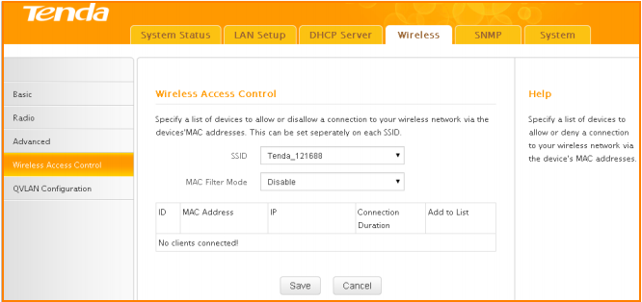

Now, you have already setup the Access Control, but you cannot access to the Internet without permitted MAC. If you have any problems, please contact our customer service, the email address is support@tenda.com.cn, thank you.

